**CS-4042 Windows Services using C#.NET -- Supplementary Guide**

1) You can check all the Win services running on your system by going into Run from your Start Menu. And then typing **services.msc**

2) Open Visual Studio. Create a new C# project and select Windows Service (with C#) as your project type.

3) Once on the default design page. Right click anywhere in the gray area and select "Add Installer".

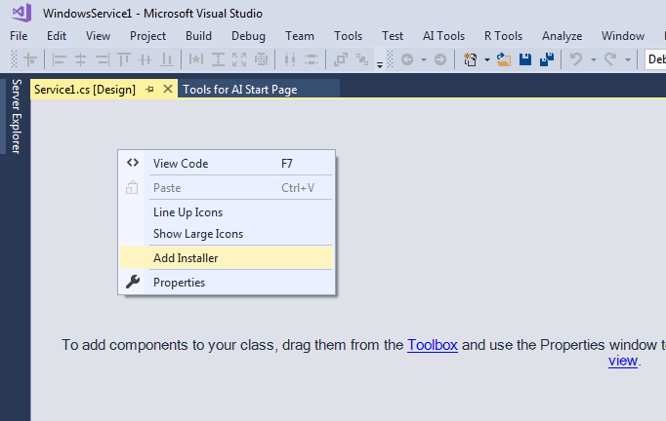

4) Once installer is added. Right click on serviceProcessInstaller1 and go to its properties (this step can also be done directly using Properties windows).

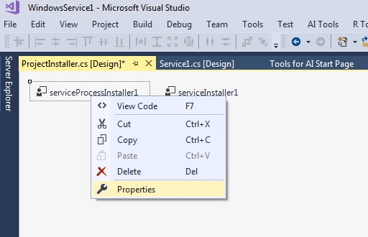

5) For our purpose we select Local System for the Account property

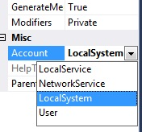

6) You can optionally rename your Service1.cs at this point.

7) Open Service1.cs from the Solution Explorer or through "Switch to Code View" option and write code for whatever actions you want your service to perform.

8) The OnStart and OnStop methods tells what the service should do when it is started/terminated.

9) You can use the code provided in the VS Solution uploaded with this guide but feel free to test it with your own code.